# 4.1 INTRODUCTION

Driven by the explosive growth of information available on the Internet, intelligent information access has become a central research area in computer science. The 20th century is commonly characterized as “The Information Age”, and the sheer amount of information readily available today has created novel challenges. Numerous intelligent information agents software tools that provide personalized assistance for users navigating large information spaces -- have been described in the literature and deployed on the World-Wide-Web However, the need for intelligent information agents is not limited to web-based applications, as we are currently witnessing an increasing trend towards “ubiquitous information access”. Different types of wireless information devices, designed to tap into the Internet’s vast information resources without physical constraints, are currently being released into the marketplace. For example, cell phones can access Internet-based information services, and pagers

can alert users of late-breaking news. While these devices undoubtedly enhance the utility of online information and are likely to open up opportunities for revolutionary information centric applications, they are cramped by several technical constraints. First, the small size of wireless information devices leads to inherently limited user interfaces. Second, bandwidth constraints impose limits on the amount of information to be transferred. Third .The World-Wide-Web is currently witnessing an ongoing trend towards personalized information access. As part of this trend, numerous personalized news services are emerging. For example, Internet portals such as Yahoo, Lycos and Excite offer personalized access to daily news stories from a large range of categories. These services are based on static questionnaires that users fill out in order to make use of news filtering capabilities. We believe that this level of personalization is not fine-grained enough for price- and bandwidth-sensitive information access. Here, we suggest the use of an intelligent news agent that unobtrusively learns about a user’s interests in daily news stories by observing the user’s browsing behavior. Using a content-based machine learning algorithm originally developed for a web-based client ,the agent learns to rank-order news stories with respect to the user’s individual interests.

In this Project, we focus on a System designed to help users access interesting news stories. System organizer as an example of a wireless information device, noting that the learning approach and interface design reported here generalize to other devices such as cell phones or two-way pagers.

# 4.2 How to Build a Successful News System:

News System are fast-paced System which track, aggregate and disseminate current news on a set range of topics. Their main selling points are **comprehensiveness** and **timeliness**: a good news System must cover the field throughly and speedily by pointing readers to new information or developments. Content for news System is published regularly on a daily basis and sometimes multiple times throughout the day. Apart from the value of the actual opinions offered by news bloggers: people subscribe to or follow these news blog largely because they help them to stay on top of current issues, innovations or ideas concerning a industry. News System are also profitable if they are monetized because they publish a very high volume of content, which continuously attracts both search and referral traffic. If you’re an entrepreneur or webmaster looking to generate some online income, a news system is a good foundation to start with because you’ll never run out of content: the **consistent news flow drives you to publish regularly**. If you’re interested in a specific field, publishing a news system forces you to keep up with what other people are talking about. It’s different from just reading other blogs because you’ll participate by contributing your own ideas or opinions. This is a good way for you to build a [strong online reputation](http://www.doshdosh.com/how-to-use-the-web-to-build-a-powerful-reputation-in-any-industry/).

### Determining Your Information Sources: An Essential First Step

One of the best ways to find interesting news is to subscribe to other systems in your niche. This includes both other news system and non-news system and that you will pay extra attention to blogs which specialize in a sub-niche because they are usually the ones who publish unique content worth mentioning.

**There are several ways to find other blogs in your niche:**

**Search Engines** :This increases the relevance of the search results.

**Blog rolls** : Some of the blogs in your niche will have blog rolls or a links page with links to other relevant blogs or news sources. This is an excellent to surf around and find other relevant blogs which cover the same topic.

**Personal Recommendations:** Sometimes the easiest way is to ask your friends or members of a forum for recommendations on sites you should check out. The benefit of personal recommendations is that you’ll almost always come across good weblogs. It’s a good way to weed out most of the junk.

**Online Newspapers and Magazines**: Online newspapers and magazines will provide you with a lot of news on your chosen topic and its a good complement to blogs and social news websites, which may sometimes overlook a particular piece of news.

Online newspapers also has the advantage of offering localized news on either a national or city-basis. This is useful if you run a news blog that is divided in country or region-based coverage. Start first by subscribing to the major news outlets like the BBC, CNN and New York Times.

**Academic Journals and Trade Publications:** Academic journals and trade publications often publish reports which you can highlight on your blog in the form of news. This usually includes polls, statistical analysis of a specific phenomenon or reports on the performance of an industry. Not all of these publications are free and some do require a paid subscription.

It’s possible to obtain complimentary copies of these academic journals regularly, if you’re a blogger with a certain degree of clout. In some scenarios, publishing houses will be willing to send you new books or journals in return for a mention on your website. It is also possible to obtain these journals by being a contributing member of a scholarly society or educational institute.

**Press Releases and Media Contacts:** When we are starting out as a relatively unknown system, we need to take the initiative to **accumulate media contacts**. Email companies and web services which are relevant to our system topical focus and inform them that you are open to receiving email press releases from their marketing/PR department.

We’ll usually be put on an email list and you can take this chance to initiate better relationships with the specific PR manager/executive. Ideally, you want to be invited to launch parties and networking events as a member of the press.

# 4.3 Design Overview:

The News Service System was designed for implementation using the JSP platform, running on Apache Tom Cat The implementation tool used to develop the system is NetBeans v6.7.1, and the language that was used is Java. However, for the purposes of testing and evaluation, the system will use a MySql database, And we using JAX-RPC for web service with a schema developed specifically for this project.

The choice of this technology was made primarily due to our desire to learn this powerful programming language and technology. Further, the initial assessment of the development environment was that it was not only suitable for large-scale web development, but that it provides excellent support for such development. It is developed and supported by one of the largest players in the software industry, and thus is not likely to disappear from the market place in the foreseeable future.

# 4.4 Object orieneted model:

We will describe our system by using object oriented model Data Flow Diagram and use case diagram.

## 4.4.1 Data Flow Diagram:

The overall system DFDs in figure 4.1 and 4.2 shows several main interfaces and processes that will govern the flow of data between the different system components, which is clearly shown down. The administrator here could represent the person responsible of running the expert system that is represented by the "Administration Order" data flow, where he enters certain predefined parameters and tables provided by the system

In the implementation of the system the expert system was replaced with a primitive sub-system called Organizer .

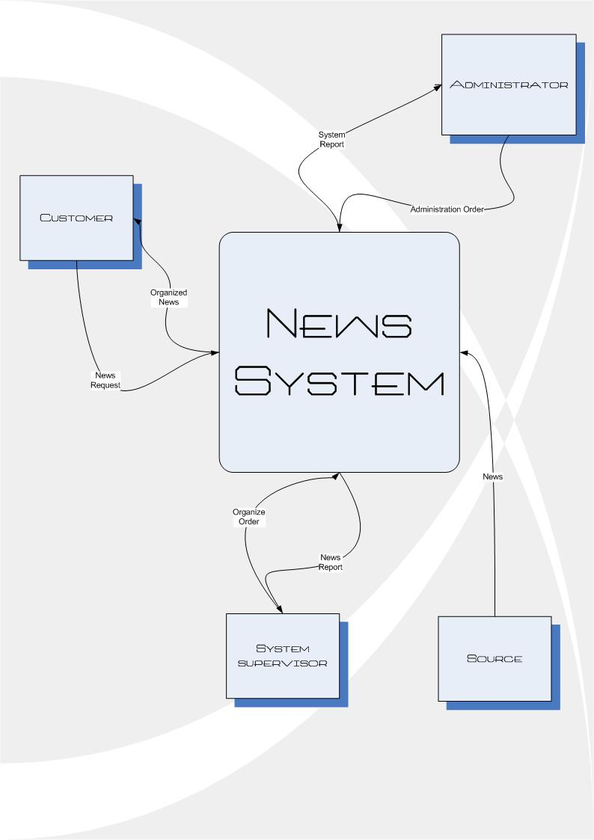

Fig 4.1 Context Diagram Of News System



Fig 4.2 Diagram 0 of News System

## 44.2 Use Case Diagram:

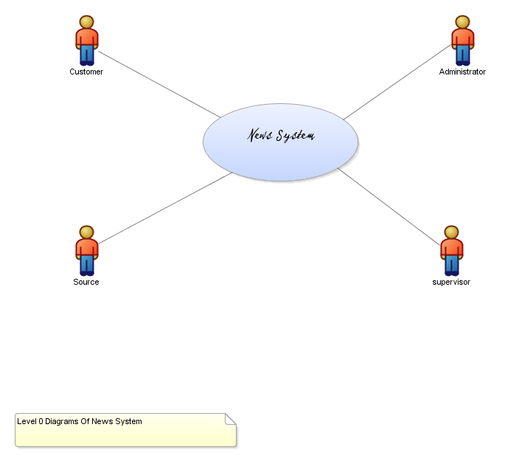

Fig 4.3 Use Case Level 0

**Brief Description**

This use case is news system its provide information and data to supervisor and to customer and get this data from source and it get administration order from administrator

**Primary Actor**

Customer

**Other Actors**

Source

Supervisor

Administrator

**Uses**

None

**Extends:** None

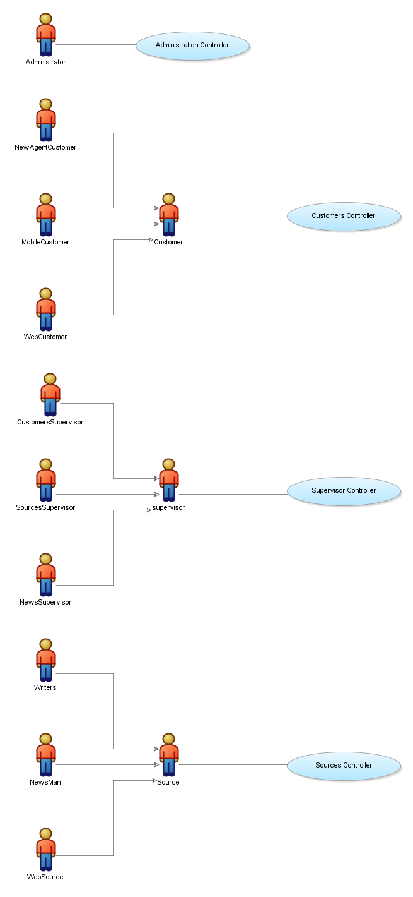Fig 3.3 Use Case Level 1

**Brief Description**

We have three use case customer controller, source controller And supervisor controller this use cases explain how the customer can get new from system and how the source provide news to the system and how the supervisor can supervising in this system.

**Primary Actor**

Customer

**Other Actors**

Source

Supervisor

Administrator

Web source

News man

Writers

Source supervisor

Customer supervisor

New super visor

Mobile customer

News agent customer

Web customer

**Uses**

None

**Extends:** None